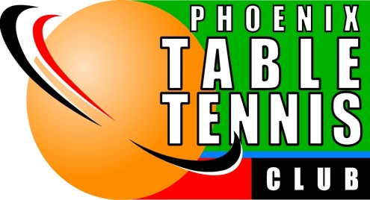
Forrest Barr
Phoenix Table Tennis Club
Sportsmanship Award

Fair play, respect for opponents and polite behavior by someone who is competing in a sport or other competition.

- 2023-2024 *** Stanley Wong
- 2022-2023 *** Dean Pedrotti
- 2021-2022 *** Tim Brannick
- 2019-2020 *** Tim Yee
- 2018-2019 *** Salvador Flores
- 2017-2018 *** Brian McBurney
- 2016-2017 *** Shelly Miller
- 2014-2015 *** Glenn Walbold
- 2013-2014 *** Chris Dardis
- 2012-2013 *** Radhakrushna Kanchanapelly
- 2011-2012 *** Jack Hu
- 2010-2012 *** Sunil Bandapally
- 2009-2010 *** Jay Turberville
- 2008-2009 *** Victor Flores
- 2007-2008 *** Brian Annest
- 2006-2007 *** Frank McGue
- 2005-2006 *** Danmin Wu
- 2004-2005 *** Thomas Migliaccio
- 2003-2004 *** Ed Jerome
- 2002-2003 *** Paul Gonzales
- 2001-2002 *** Gia Leu
- 2000-2001 *** Jay Jett
- 1999-2000 *** Bob Ryberg
- 1998-1999 *** Sy Kenig
- 1997-1998 *** Jerry Whelpley
- 1996-1997 *** Jim Tarkowski
- 1995-1996 *** Derrick Cone
- 1994-1995 *** Leroy Meyers
- 1993-1994 *** Evans Oswald
- 1992-1993 *** Dan Bryan
- 1991-1992 *** John Harrington
- 1990-1991 *** Ernie Thompson
- 1989-1990 *** Gunter Pawlowski
- 1988-1989 *** Bill Baker
- 1987-1988 *** Wayne Johnson
- 1986-1987 *** Stephanie Dillard
- 1985-1986 *** Gene Lew
- 1984-1985 *** Steve Ryberg
- 1983-1984 *** Pam Jaffe
- 1982-1983 *** Jean Barrington

